**POSTGRESQL REST USER AND PUB-SUB USERS**

REF:

<https://caronates.wordpress.com/2010/01/12/comandos-para-postgres/>

<https://www.postgresql.org/docs/8.1/static/app-psql.html>

<https://www.postgresql.org/docs/9.1/static/sql-alterdatabase.html>

<https://stackoverflow.com/questions/4313323/how-to-change-owner-of-postgresql-database>

<https://www.postgresql.org/docs/9.0/static/sql-grant.html>

IN ORDER TO ACHIEVE THIS GOAL, WE HAVE TO DO NEXT:

1. LOGIN WITH POSTGRES UNIX USER TO ACCESS OUR POSTGRESQL DATABASE INSTANCE WITH COMMAND: ***sudo –i –u postgres***
2. ACCESS TO PSQL RUNNING ***psql***
3. INSERT PASSWORD
4. CREATE NEW USER TO CONNECT TO OUR DJANGO REST FRAMEWORK BACKEND SERVER WITH COMMAND: ***create user drf_user with password ‘password’;***
5. CHANGE MAIN DATABASE OWNER WITH COMMAND: ***alter database drf_reactive_db owner to drf_user;***

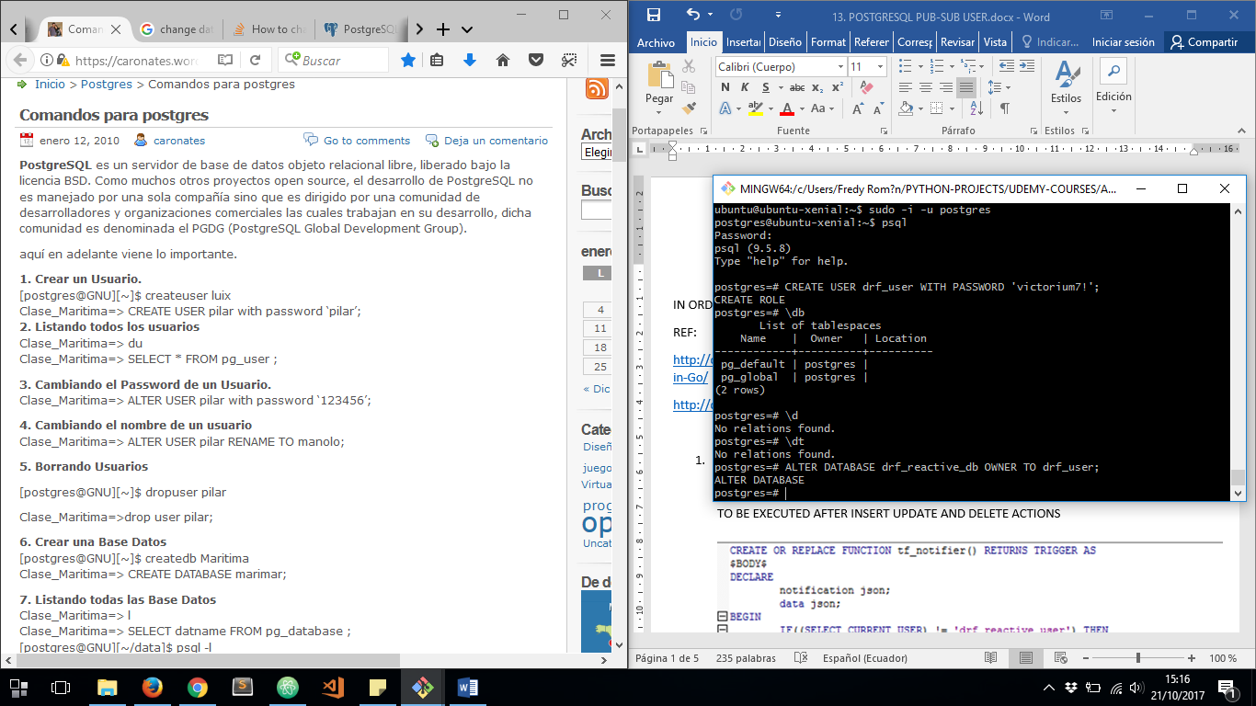



NOW LET’S GRANT SOME PRIVILEGES TO OUR NEW DJANGO-REST FRAMEWORK ACCESS USER, RUN NEXT COMMAND TO REFER EACH TABLE OF THE DATABASE: ***grant select, insert, update, delete on <table_name> to <db_user>;***

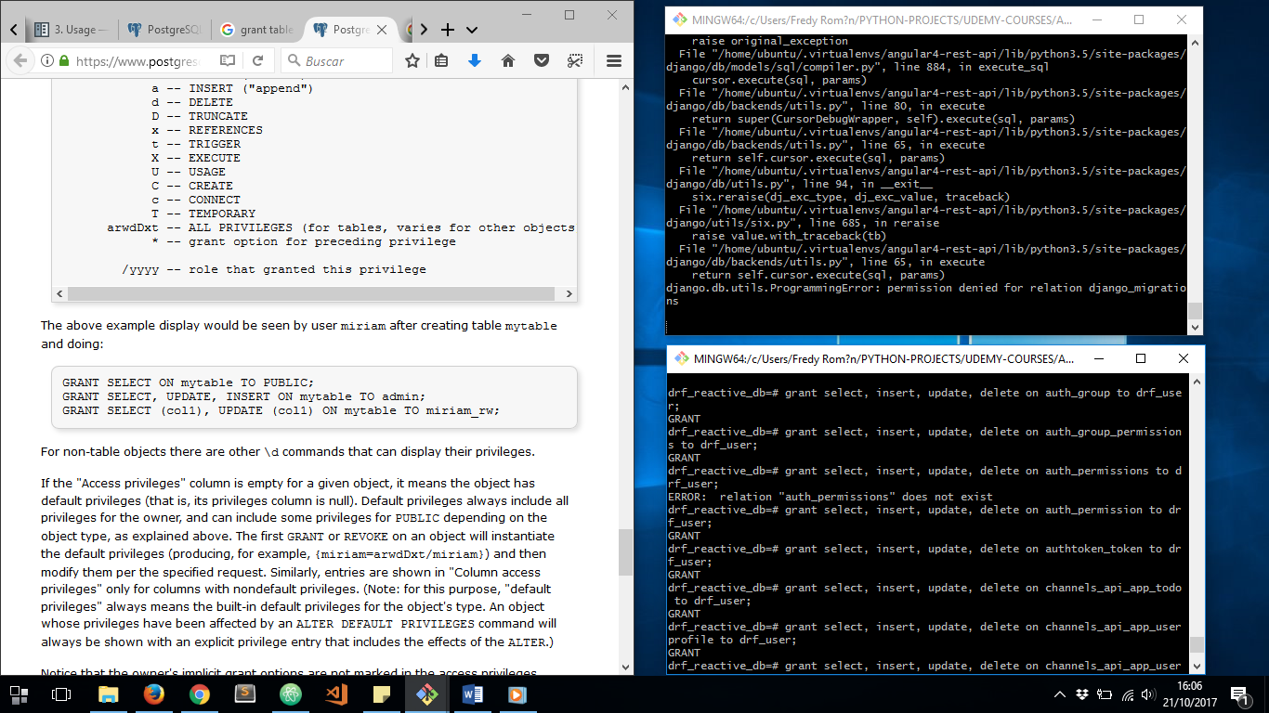

NOW IT’S TIME TO CHANGE DATABASE ACCESS CREDENTIALS ON DJANGO-REST-FRAMEWORK ***settings.py***

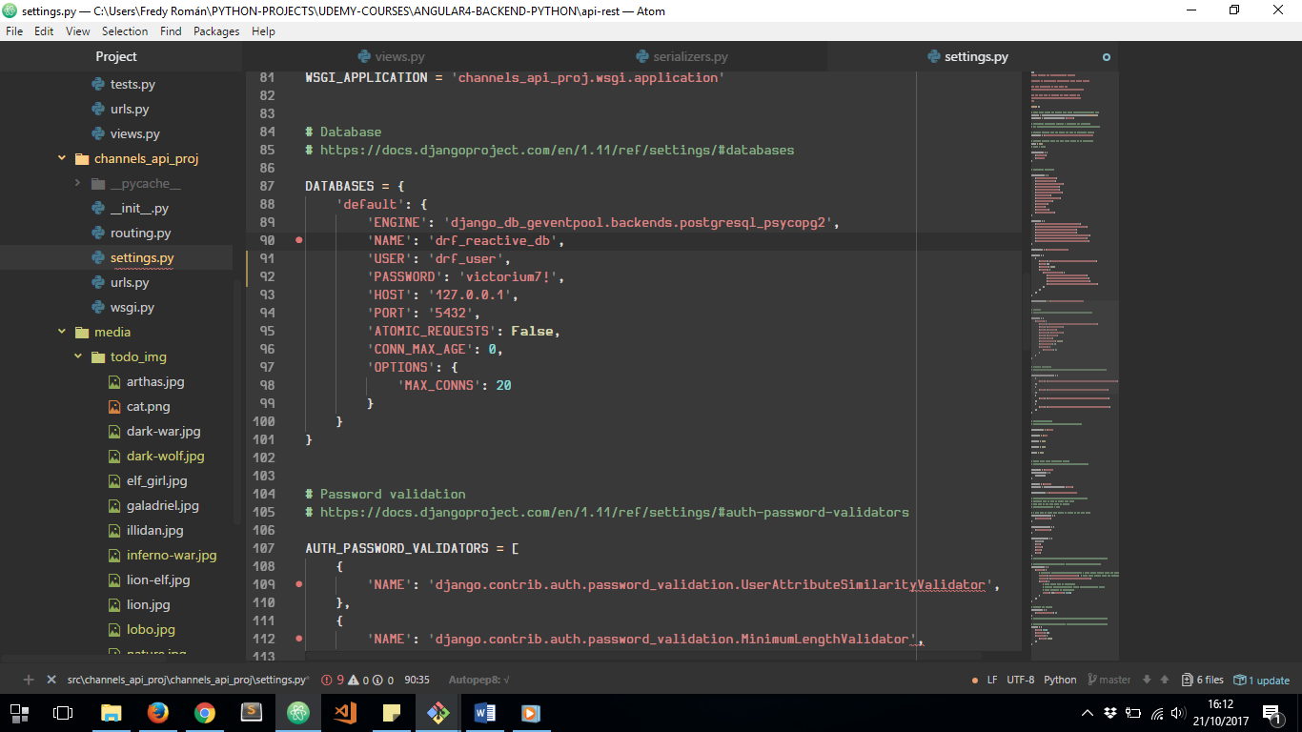

NEXT TO DO IS ALTER DATABASE TRIGGER TO SEND NOTIFICATIONS WHEN CHANGES COME TO TODO TABLE:

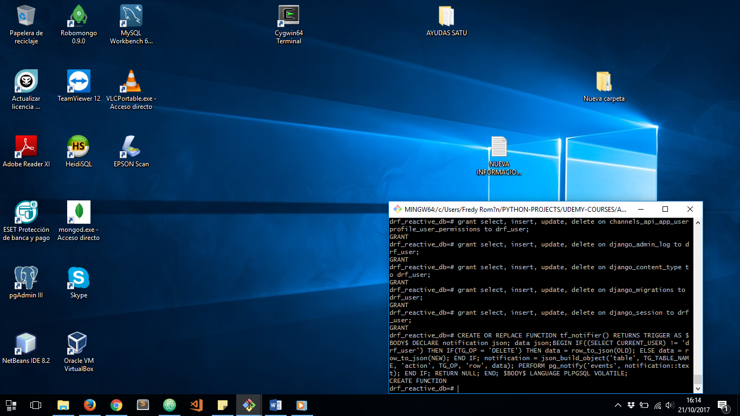

WE’RE SPECIFYING JUST ***drf_user*** CANNOT PROPAGATE CHANGES TO FRONT-END CLIENTS TRHOUGH BACKEND AND MIDDLEWARE SERVERS RESPECTIVELY, BECAUSE THIS IS THE USER USED BY DJANGO-REST-FRAMEWORK BACKEND TO ACCESS THE DATABASE AND PUBLISH THE REST API. ANY OTHER USER CAN PROPAGATE CHANGES TO THE FRONT-END:

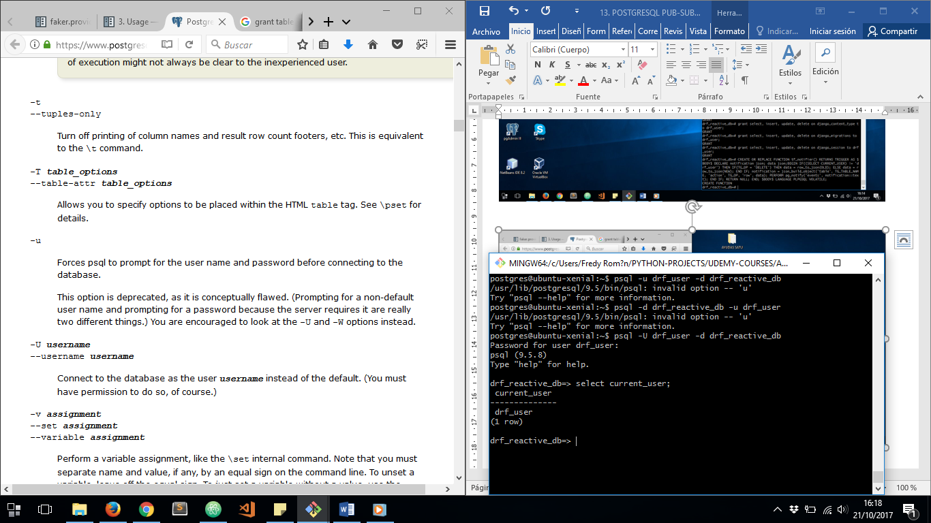

WE CAN VERIFY WHICH IS THE CURRENT USER FROM DATABASE PSQL COMAND LINE

NOW LET’S TEST OUR WHOLE PLATFORM WITH A DATABASE USER TO BE USED TO REST API AND DIFFERENTIATE OTHER DATABASE USERS WHEN THEY MAKE ANY CHANGES TO TODO TABLE FROM THE DATABASE DIRECTLY AND SEE HOW OUR MIDDLEWARE SERVER CATCHES THE NOTIFICATION:

SEE HOW REST API DATABASE ACCESS USER CANNOT PROPAGATE NOTIFICATION CHANGES TO OUR MIDDLEWARE SERVER. WE ARE USING DJANGO REST FRAMEWORK ADMIN SITE:

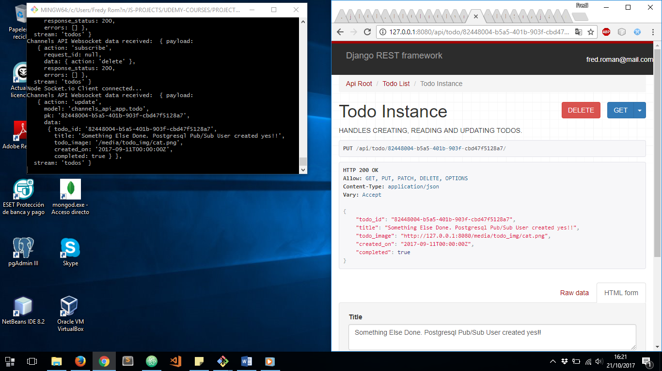

ANY TORNADO WEBSOCKET CHANGES COMMING TO OUR EXPRESS.JS MIDDLEWARE SERVER. JUST CHANNELS API OF OUR REST SOCKET SERVER PROPAGATES NOTIFICATIONS BUT NOT FROM DATABASE DIRECTLY:



NOW SEE WHAT HAPPEN IF WE LOGIN WITH OTHER USER TO PSQL DATABASE COMMAND LINE, AND THE MAKE A CHANGE IN OUR TODO TABLE:

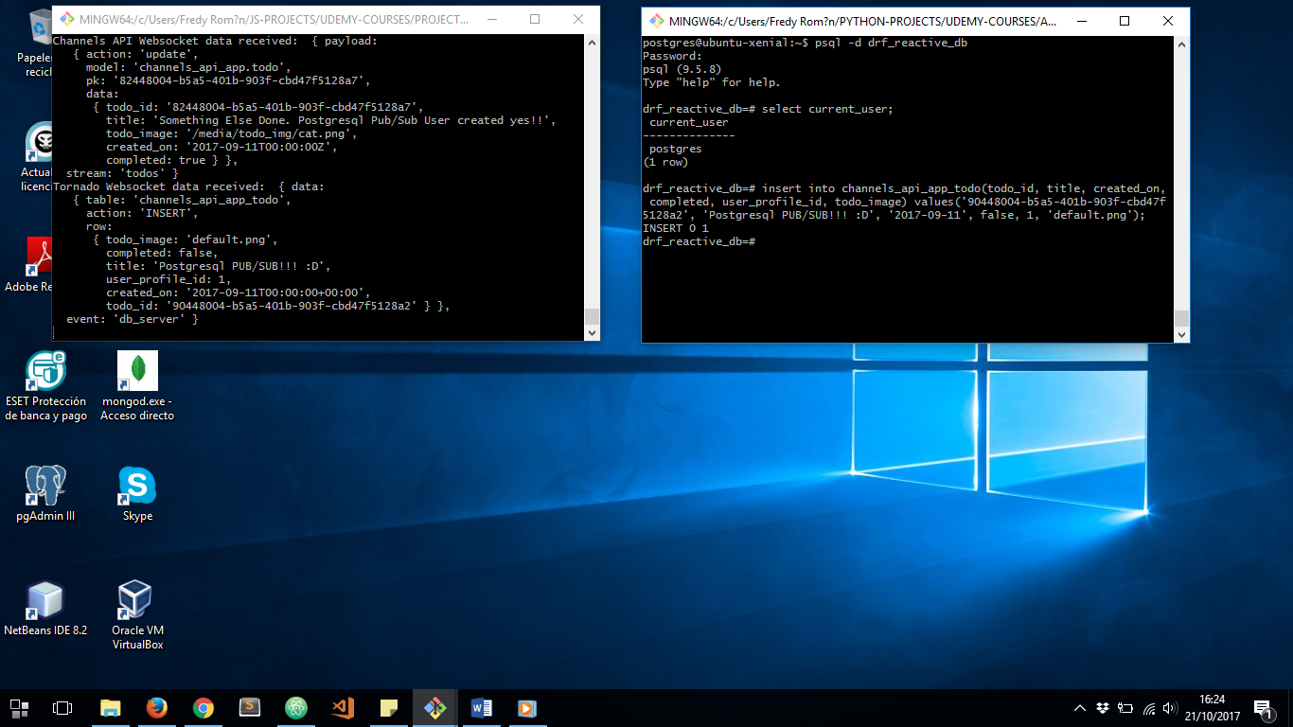

NOW THE PAYLOAD COMES FROM TORNADO WEBSOCKET WHICH CATCHES PUB/SUB NOTIFICATIONS FROM POSTGRESQL DATABASE DIRECTLY:

